**Use the diagram to complete each statement.**

A

B

C

D

E

F

G

H

1. All lines parallel to :
2. All lines perpendicular to :
3. All lines skew to :
4. Plane BCG is parallel to plane ________.

**Use the diagram to complete the statement with corresponding, alternate interior, alternate exterior, or consecutive (same-side) interior then circle their relationship.**

1. 2

3 4

1. 6

7 8

1. 3 and 5 are _______________________ angles.

Congruent Supplementary

1. 2 and 7 are _______________________ angles.

Congruent Supplementary

1. 2 and 6 are _______________________ angles.

Congruent Supplementary

1. 4 and 5 are _______________________ angles.

Congruent Supplementary

1. 3 and 7 are _______________________ angles.

Congruent Supplementary

**Find the measure of each** angle Given: m 1 = 110˚

1 2

3 4

5 6

l

j

10. m 2 = ________

m 3 = _______

m 4 = ________

m 5 = ________

m 6 = ________

**Name the angles and state the relationship. Then find the value of x.**

2x˚

124˚

l

m

11. 12.

65˚ (3x + 35)˚

l

m

Name: Name:

Relationship: Relationship:

x = _____ x = ________

13. 14.

(4x + 6)˚

l

m

(x+36)˚

­

(x + 15)˚

(2x)˚

Name: Name:

Relationship: Relationship:

x = _____ x = _______

**Use the diagram to state whether the given angles are supplementary or congruent.**

1 2

3 4

1. 6

7 8

15. 2 and 6 are _________________________.

16. 3 and 5 are _________________________.

17. 1 and 2 are _________________________.

**Find the slope of the line that passes through the given points.**

18. Points A(2, 2) and B(-2, -6) 19. Points A(-6, -2) and B(6, 4)

**Determine if the following lines are parallel, perpendicular, or neither.**

20. Line 1: through (-3, 1) and (-2, -4) 21. Line 1: through (2, 2) and (9, 1)

Line 2: through (8, -6) and (7, -1) Line 2: through (4, 5) and (3, -2)

**Find the slope of the line provided. Graph and state the slope of a line parallel and perpendicular.**

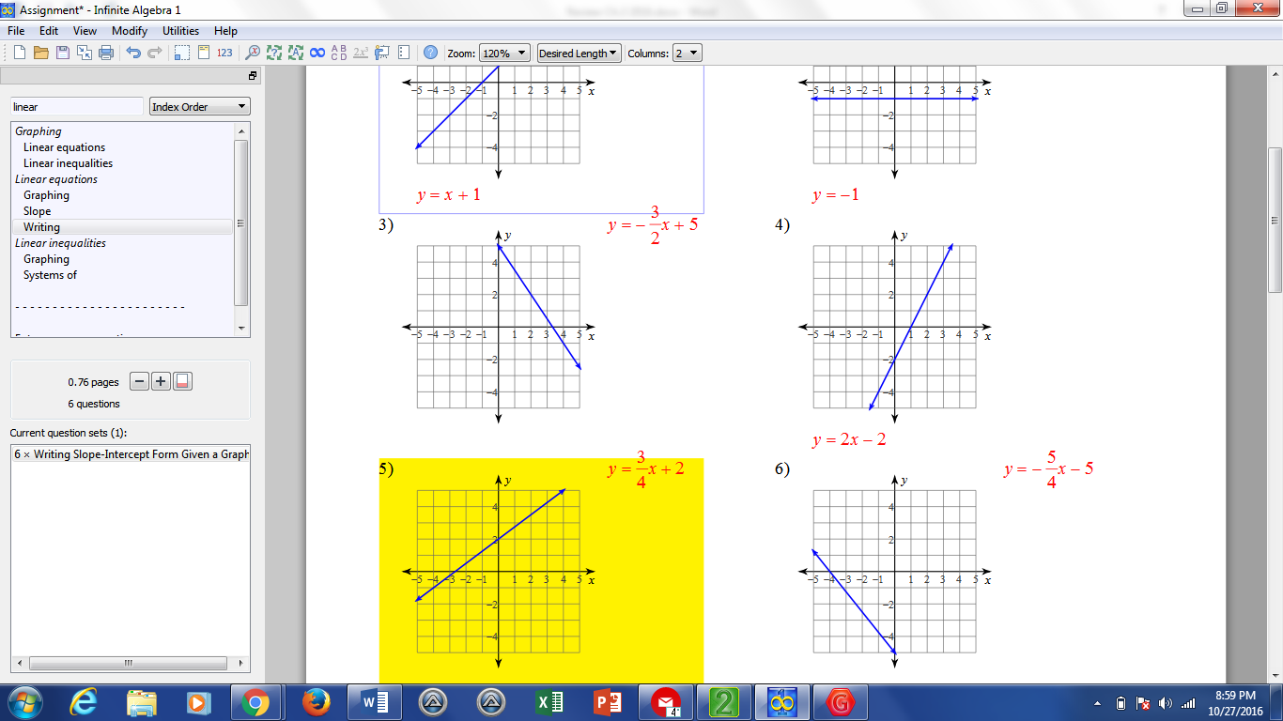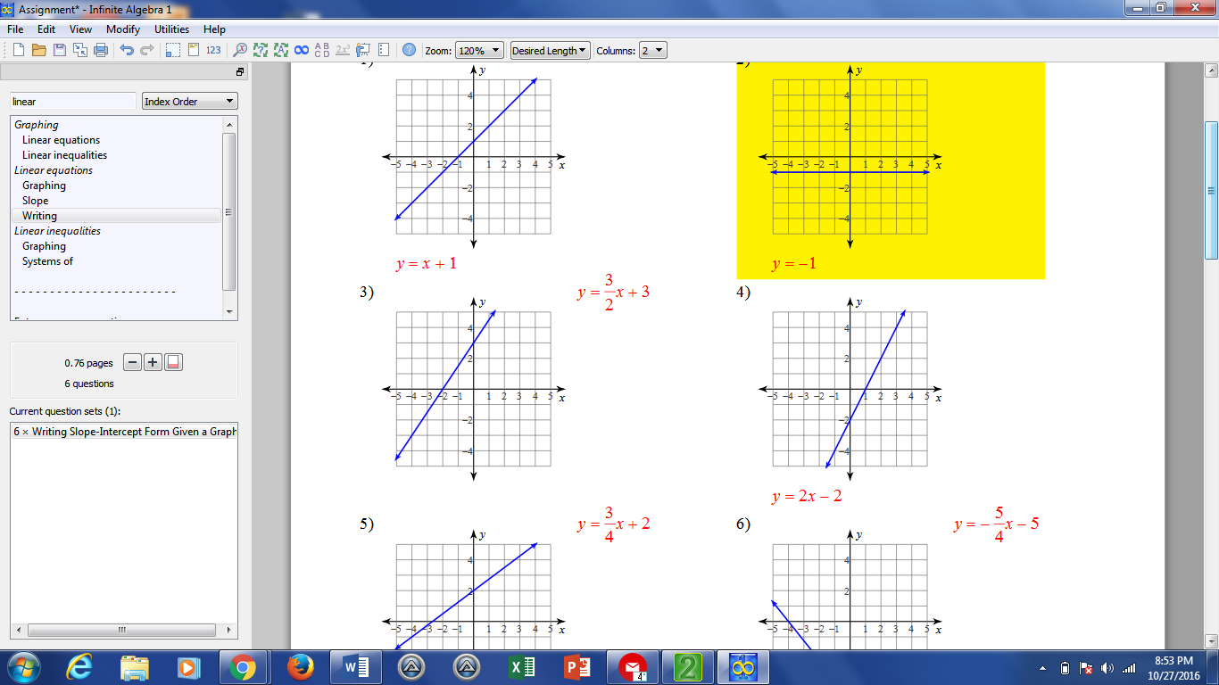22. 23.

**Decide whether the lines with the given equations are perpendicular, parallel, or neither.**

1. m = 4 25. m = 2

m = 2 m = $-\frac{1}{2}$

1. m = 5 27. m= $-\frac{3}{2}$

m = 5 m = $-\frac{2}{3}$

**Using the drawing provided, write statements that proves the following are true**.

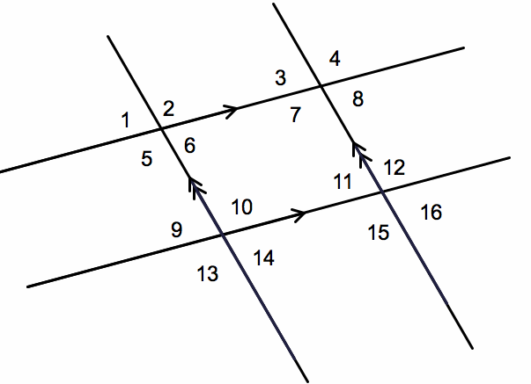

28. Prove that

29. Prove that $<9≅ <3$

**Write the equation of the line parallel to the given line, through the given point.**

30. parallel to through point (9, -4)

31. parallel to 4x + 2y = 8 , through point (-2, 5)

**Write the equation of a line perpendicular to the given line, through the given point.**

32. perpendicular to y = -4x + 6, through the point (-8, 3).

33. perpendicular to 9x + 12y = 6, through the point ( -6, 2)